DYNAMODE DYNA-GD309 LockStock Series Gaming ATX/M-ATX Computer Case Gaming Pc Case With Fans - Black Design Gamer PC Case

GC783

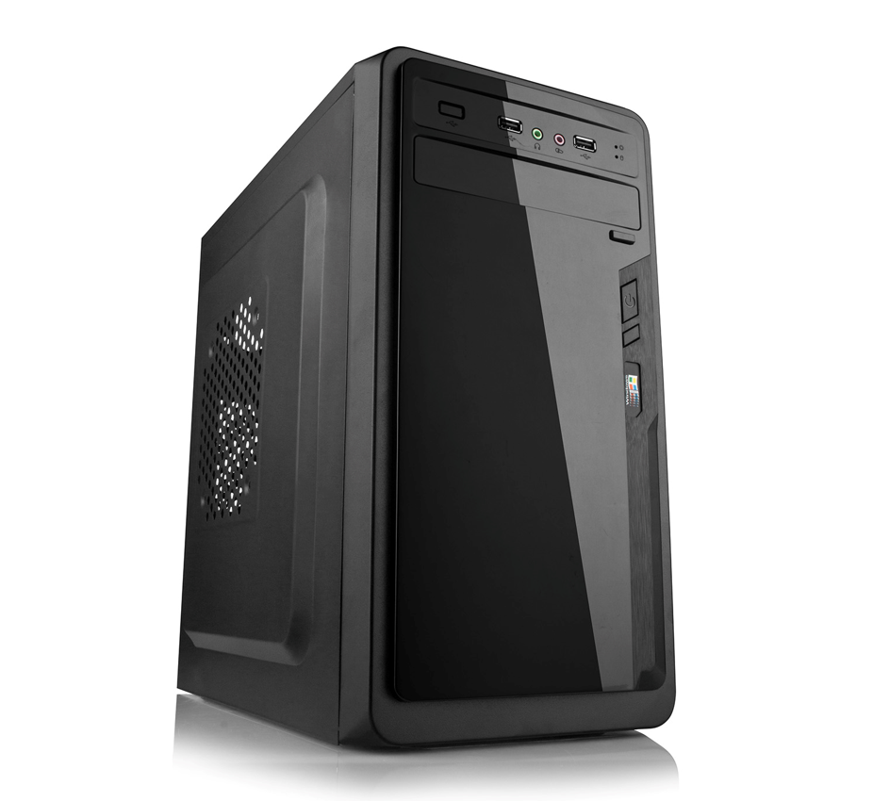

About this item
- BUILT WITH YOUR IMAGINATION | Introducing the new range of Dynamode LockStock PC cases which will bring a new, exciting dimension to your computer system builds and add a futuristic presence for your powerful system hardware.
- COOL DOWN SUPERIOR AIR FLOW | But the beauty is not just skin deep. Under the hood is extensive cooling options to help keep the most overclocked ATX or M-ATX motherboard running as it should together with a generous array of 3.5” and 5.25” storage array compartments.
- DESIGNED FOR YOUR HAPPINESS | External USB and Audio (dependent on model) are incorporated as we know this means less hassle when connecting your USB peripherals.
- GAMERS CHOISE | Finally we know you need need ease of access to your valuable hardware, so all Dynamode LockStock cases are just that - easy to build, and built to last.
- KEEP YOUR HARDWARE SAFE AND COOL | Superior system venting and PC component connection
- HOW MANY PORTS YOU NEED | Front Ports: x1 Audio, x1 USB2, x1 USB3, PCI Slots: x7 Fan Ports: x1 Front, x1 Back, x3 Side of case
- Storage Fitment: x1 5.25”, x3 3.5” devices
- Lightweight alloy dimensions: 370x173x405mm (approx)
- Easy Access chassis design - ideal for all PC system builders
- Compatible with standard ATX, MicroATX Motherboards *

Structure material：0.35mm &0.40mm SGCC
Structure size: 370*173*405mm
Motherboard support: ATX/Micro ATX
Power support: Standard ATX PSU
PCI Slot: 7 slots
Fan support: Rear 1*8cm , side 2*12cm, front 1*12cm
ODD space support: 2*5.25''
HDD space support: 3*3.5''
SSD space support: 2*2.5''
FDD space support: 1*3.5''
Front panel ports: Audio+2*USB
Front panel material: ABS
Front panel color: customized
Package size: 445*220*455mm

